# [Project]

**DETAIL DESIGN DOCUMENT**

**Screen design**

**Project Code:**

**Document Code: <Project code>-DD – v<Version>**

**<Location, issued date of the Document>**

**RECORD OF CHANGE**

#### *A - Added M - Modified D – Deleted

|  |  |  |  |  |
| --- | --- | --- | --- | --- |
| Effective Date | Changed Items | A* M, D | Change Description | New Version |
|  |  |  |  |  |
|  |  |  |  |  |
|  |  |  |  |  |
|  |  |  |  |  |
|  |  |  |  |  |
|  |  |  |  |  |
|  |  |  |  |  |
|  |  |  |  |  |
|  |  |  |  |  |
|  |  |  |  |  |
|  |  |  |  |  |
|  |  |  |  |  |
|  |  |  |  |  |

**SIGNATURE PAGE**

**ORIGINATOR:**<Name> <Date>

#### <Position>

**REVIEWERS:** <Name> <Date>

#### <Position>

<Name, if it’s needed> <Date>

<Position>

**APPROVAL:** <Name> <Date>

#### <Position>

MỤC LỤC

### SCREEN FLOW

<Screen structure or transition between screens. It should be in diagram>

<List of screen>

|  |  |  |
| --- | --- | --- |
| **No** | **Screen Name** | **Description** |
| 1 | Home |  |
| 2 | Login |  |
| 3 | Manager product |  |
| 4 | Request product |  |
|  |  |  |
|  |  |  |
|  |  |  |

## Home

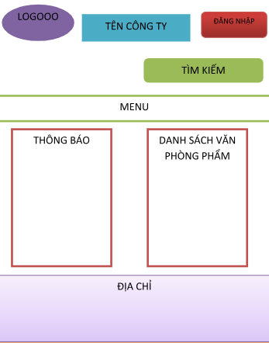

|  |  |  |  |  |  |
| --- | --- | --- | --- | --- | --- |
| **No** | **Component Name** | **Required** | **Format** | **Reference** | **Note** |
| 1 | Menu | Yes |  | *How to get data or save data from screen* |  |
| 2 | Image Logo | Yes |  |  |  |
| 3 | Box Search | Yes |  |  |  |
|  |  |  |  |  |  |

* 1. **Login**

LOGIN

Username

Input username

Password

Password

User

LOGIN

REGISTER

XX

Admin

|  |  |  |  |  |  |
| --- | --- | --- | --- | --- | --- |
| **No** | **Component Name** | **Required** | **Format** | **Reference** | **Note** |
| 1 | TextBox Username | Yes |  | *How to get data or save data from screen* |  |
| 2 | CheckBox User |  |  |  |  |
| 3 | CheckBox Admin | Yes |  |  |  |
| 4 | Button Login | Yes |  |  |  |
| 5 | Button Register | Yes |  |  |  |

* 1. **Manager product:**

|  |  |  |  |  |  |
| --- | --- | --- | --- | --- | --- |
| **No** | **Component Name** | **Required** | **Format** | **Reference** | **Note** |
| 1 | TextBox | Yes |  | *How to get data or save data from screen* |  |
| 2 | Button Edit | Yes |  |  |  |
| 3 | Button Delete | Yes |  |  |  |